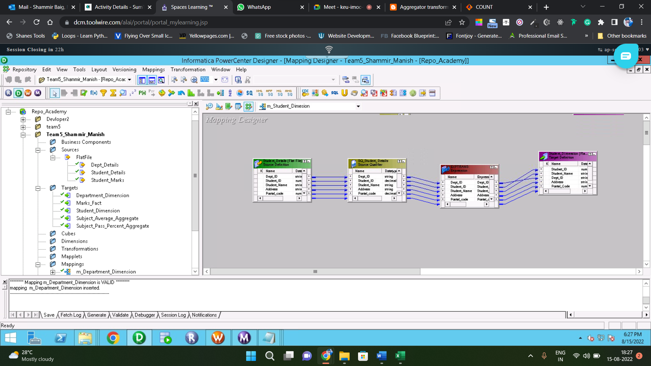

MAPPING OF STUDENT DIMENSION

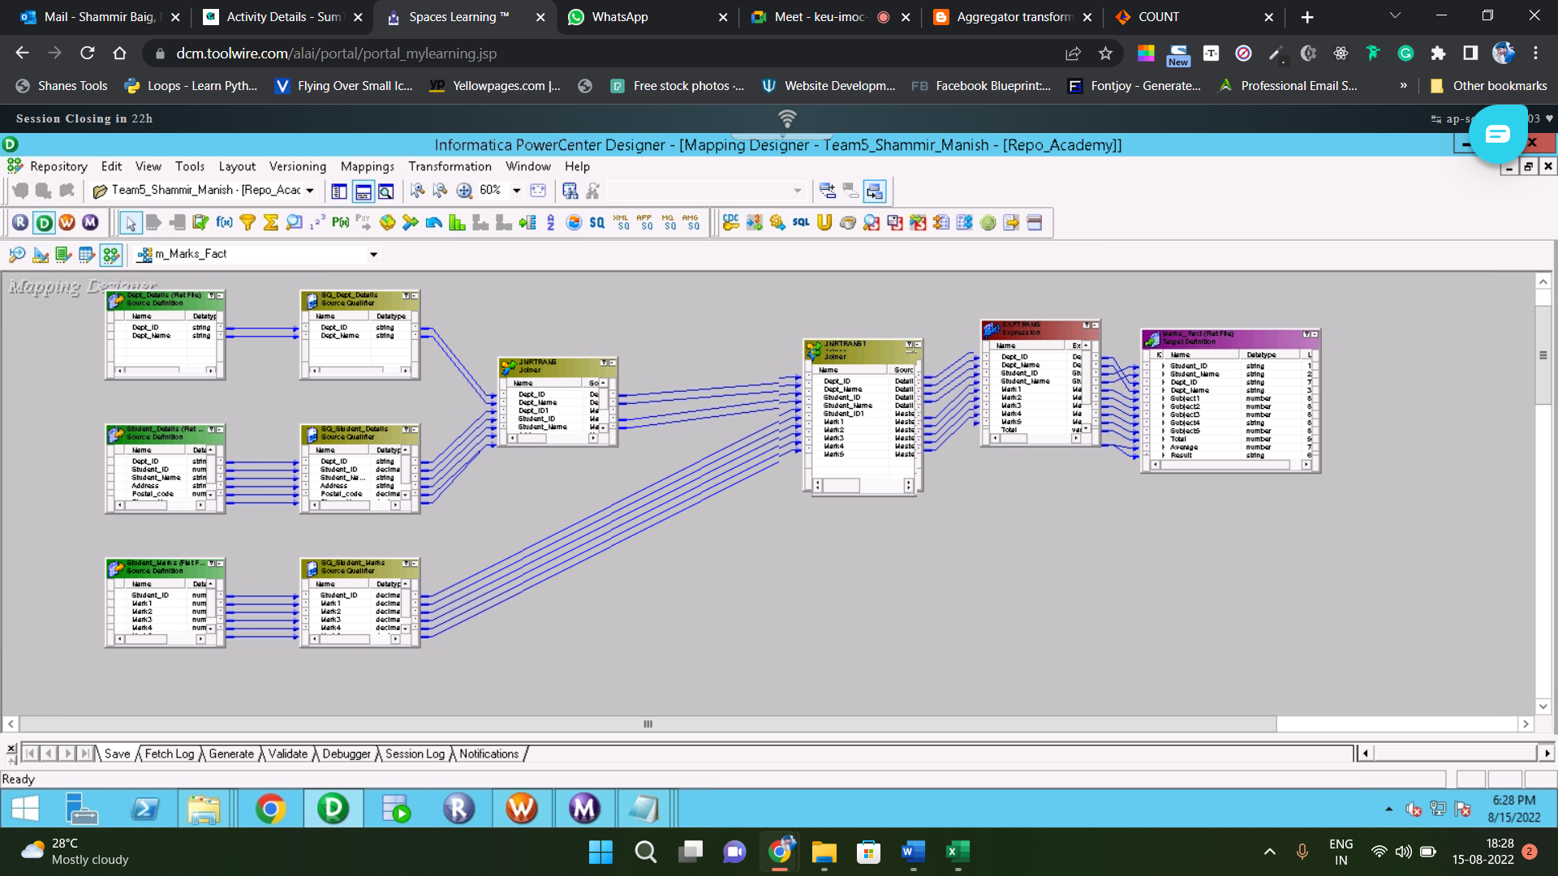

MAPPING OF MARKS FACT

MAPPING OF SUBJECT AVG AGGREGATE

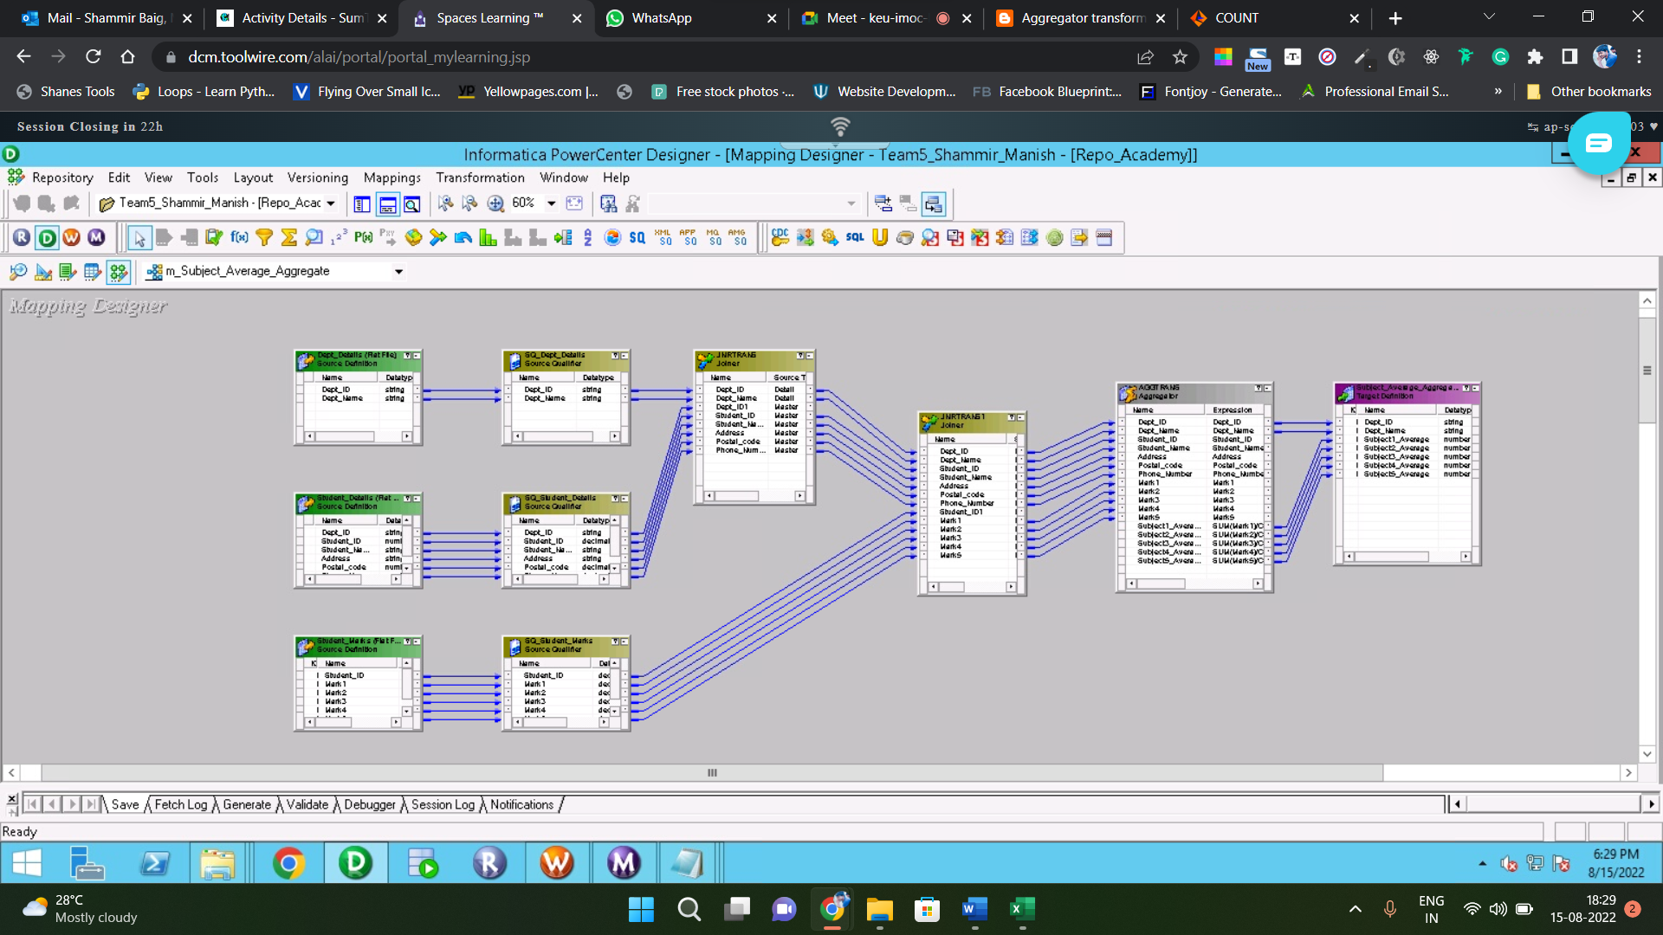

MAPPING OF SUBJECT PASS PERCENTAGE

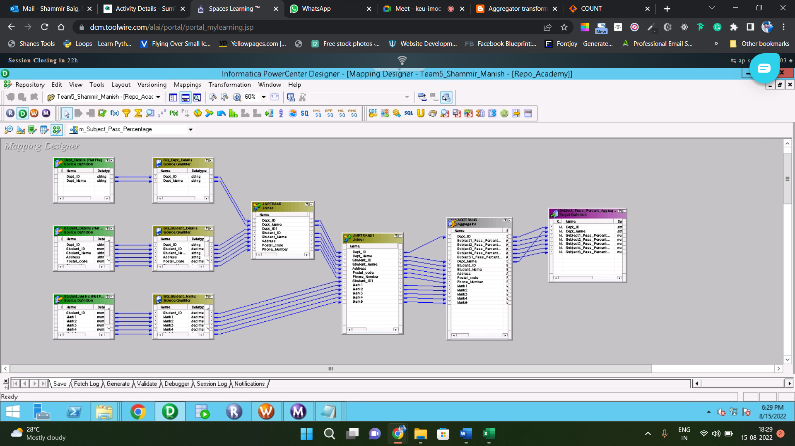

MAPPING OF DEPARTMENT DIMENSSION

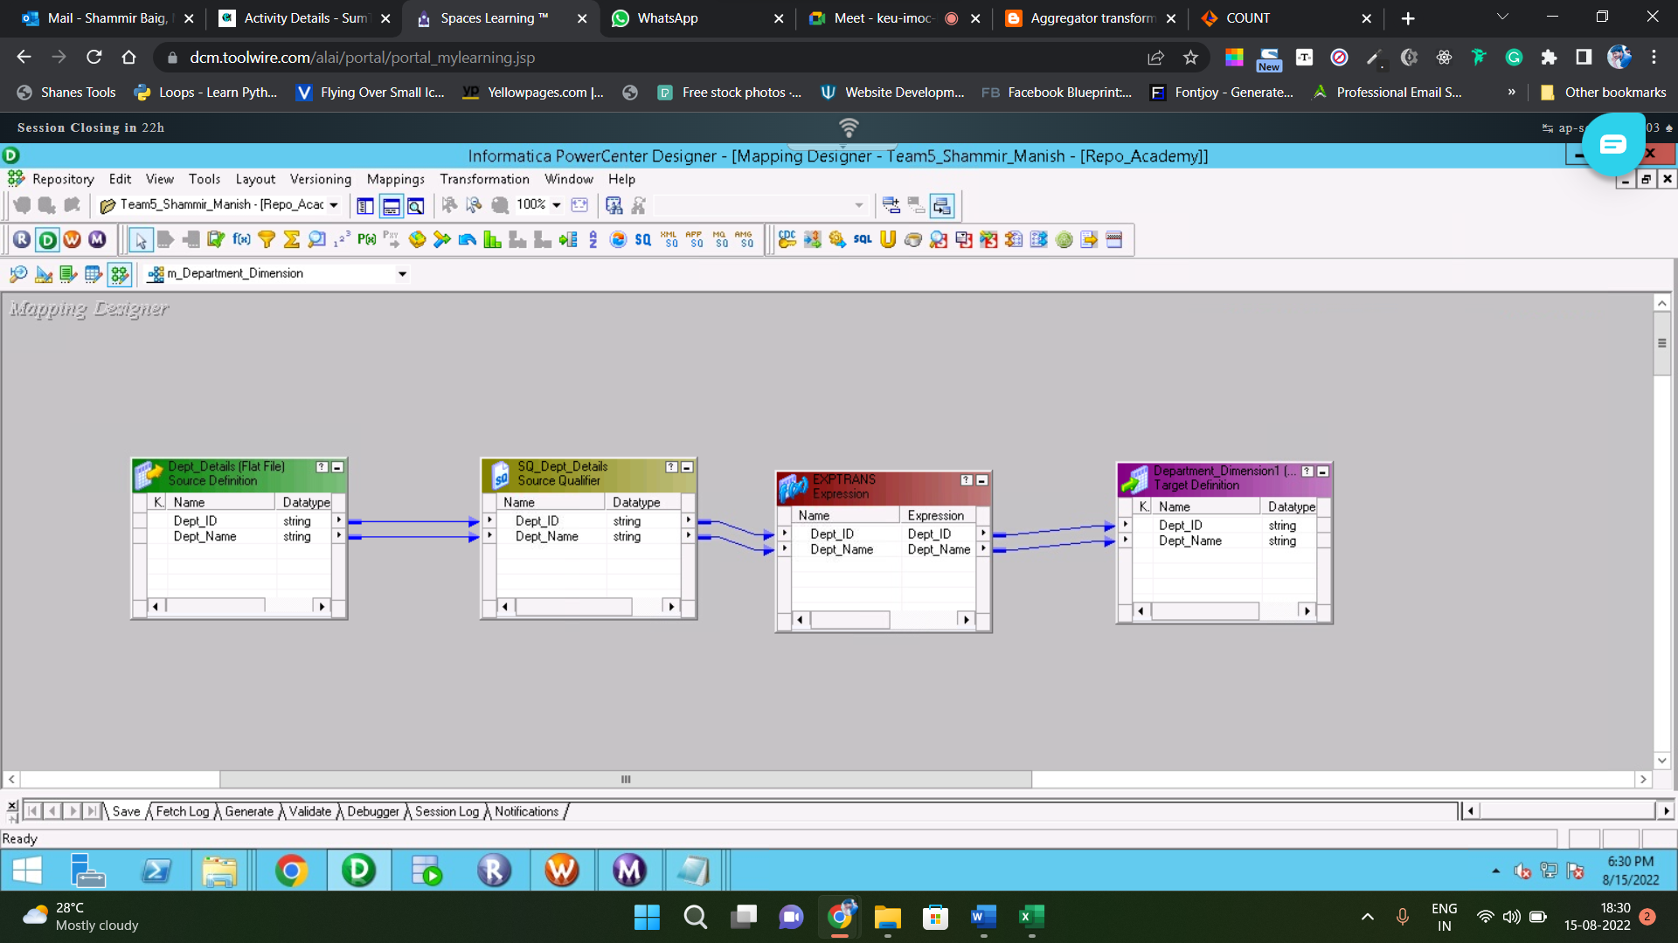

WORKFLOW MONITOR

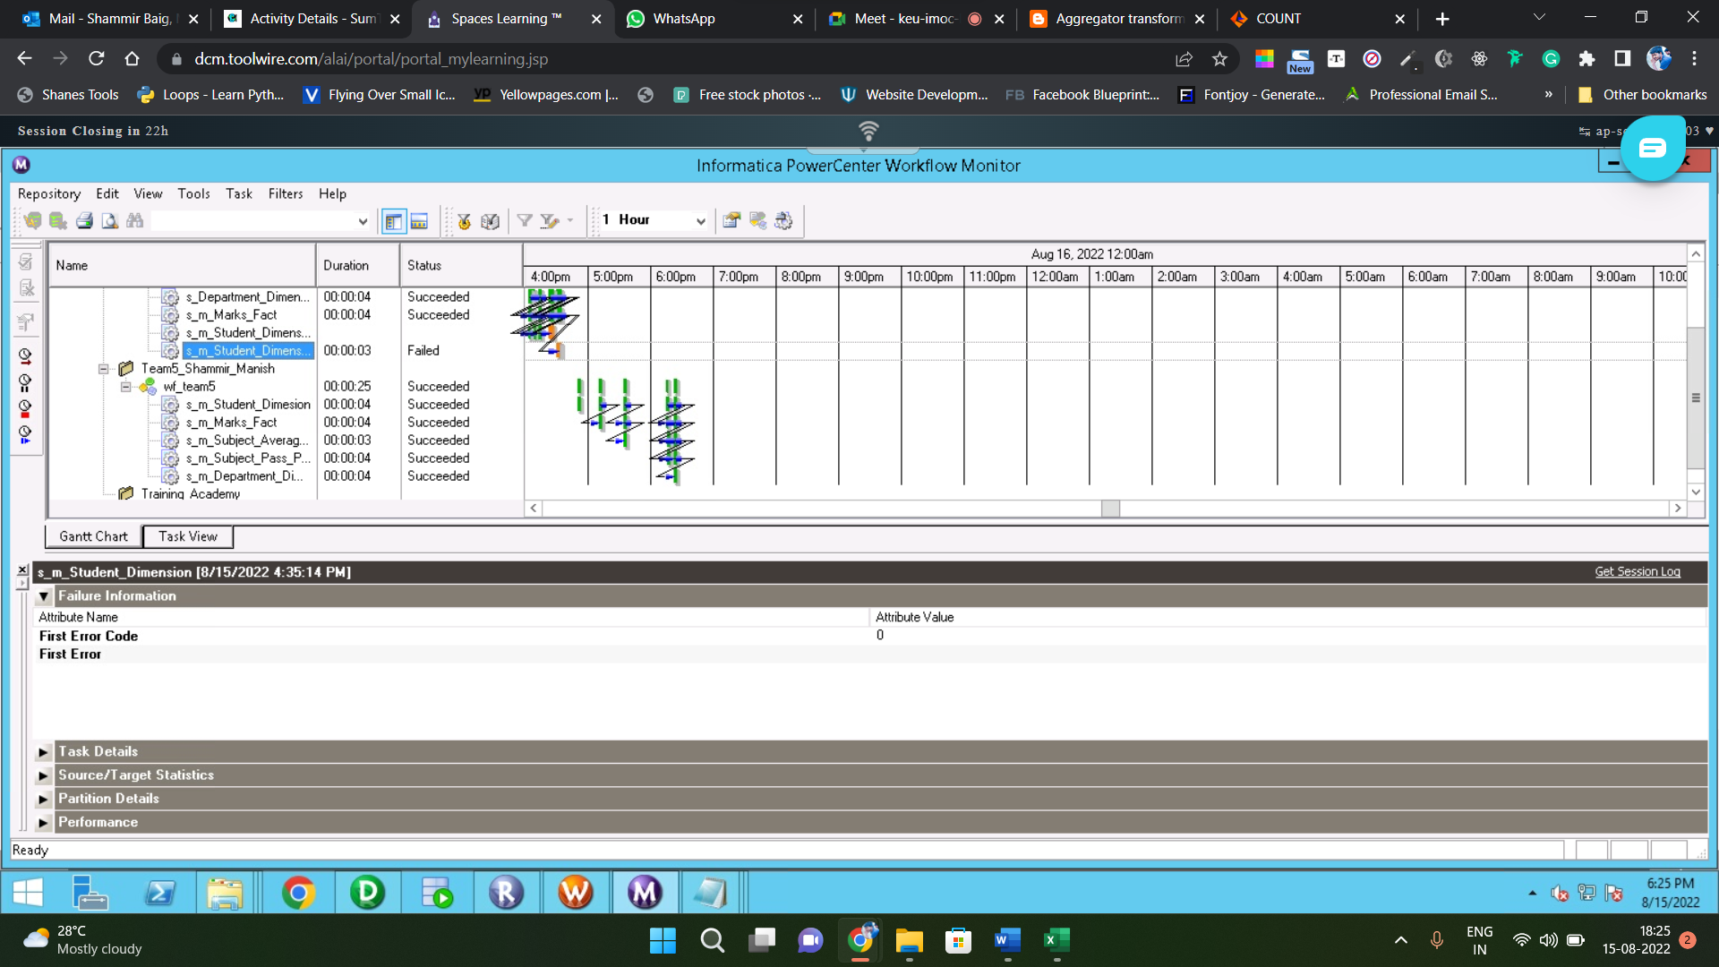

WORKFLOW MANAGER

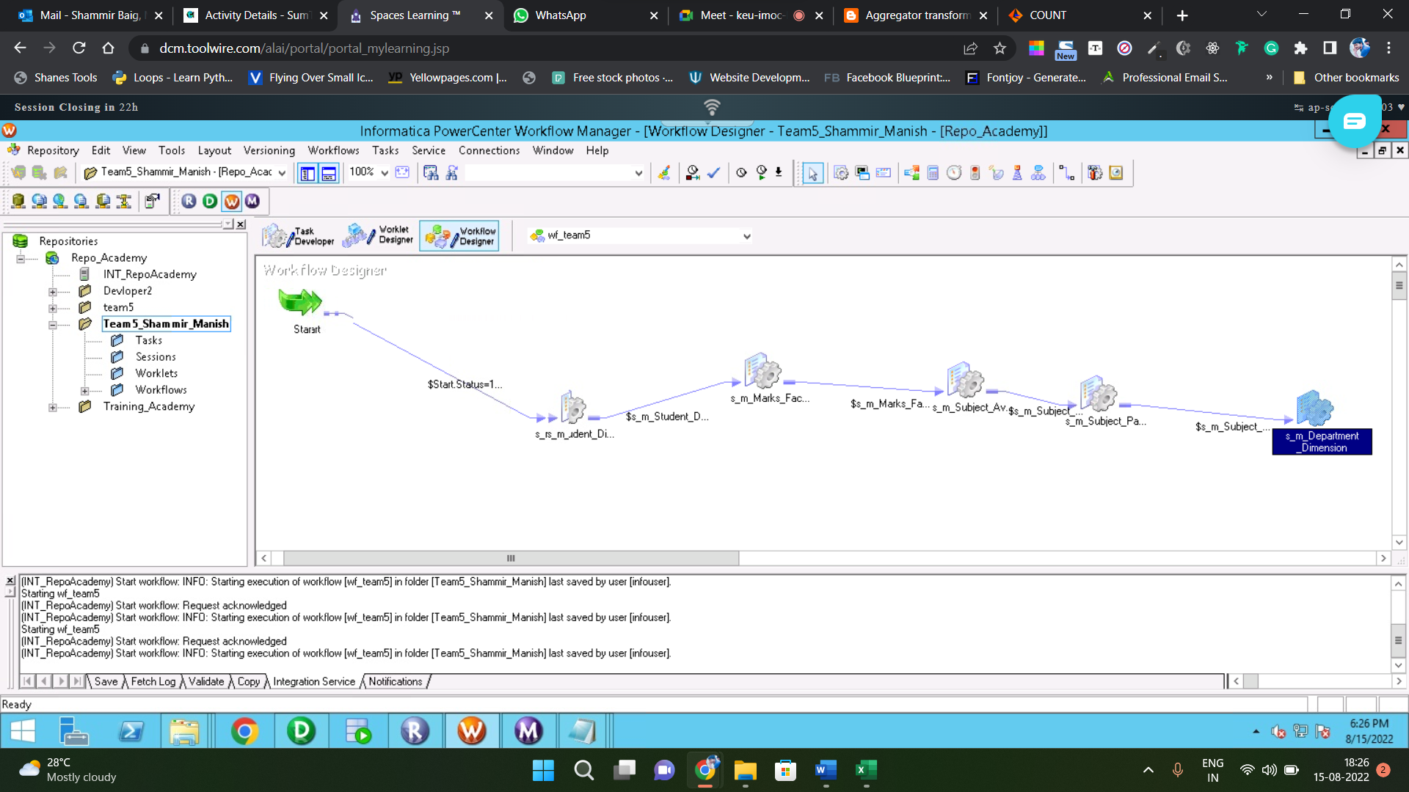

REPOSITORY MANAGER

